## Admin login with valid details

Expected Result: Admin is directed to admin panel

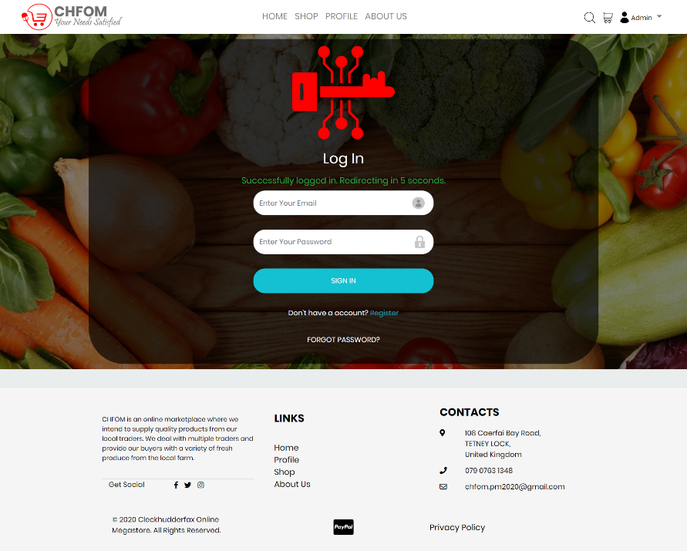

## Admin login with invalid details

Expected Result: Error message is displayed, and login is disallowed 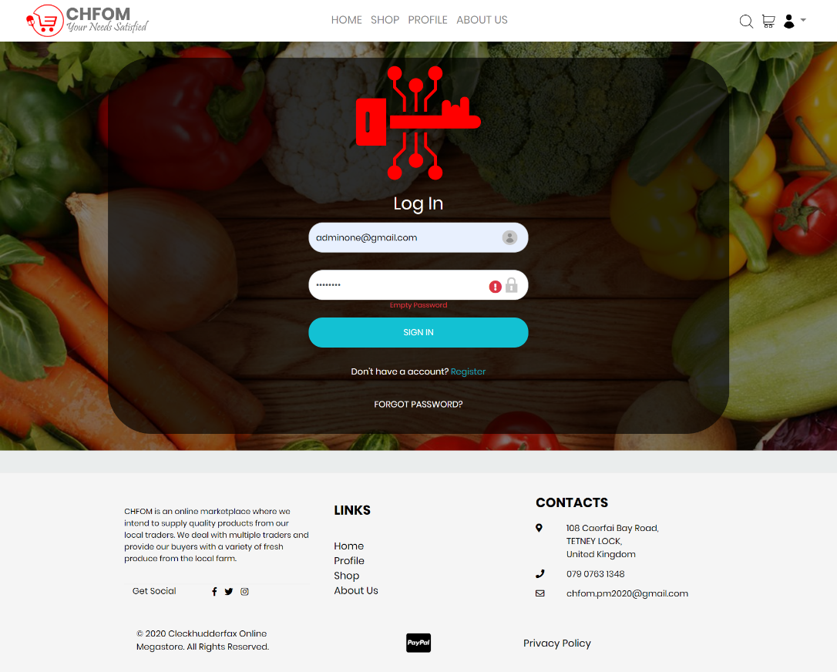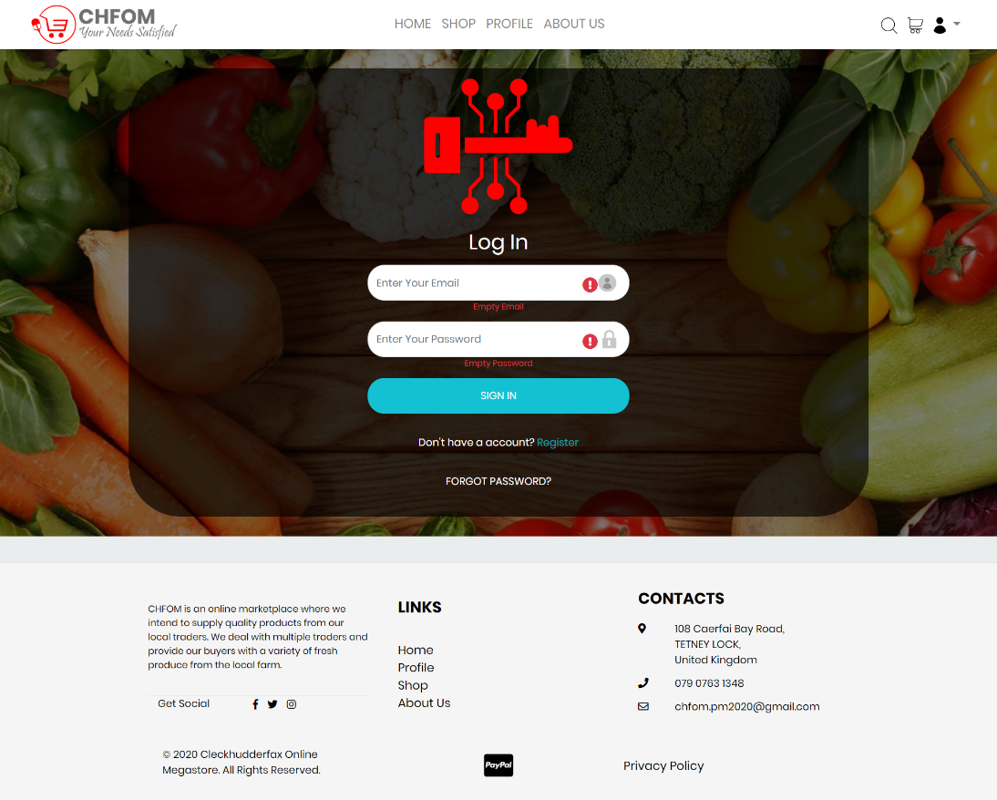

## Manage Trader

Expected Result: Trader's proposal is either approved or rejected by admin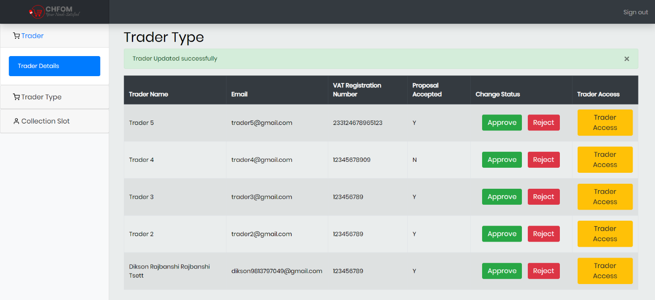

## Manage Trader Type

Expected Result: 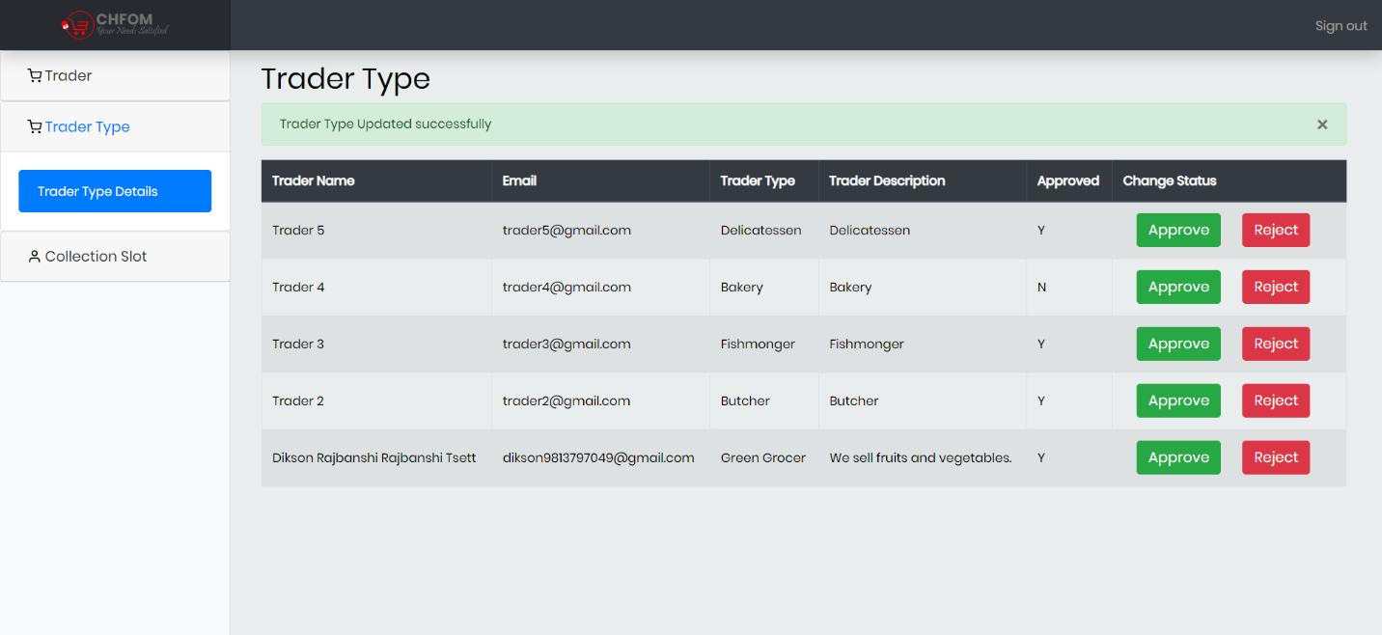

## Manage Collections Slots

Expected Result: 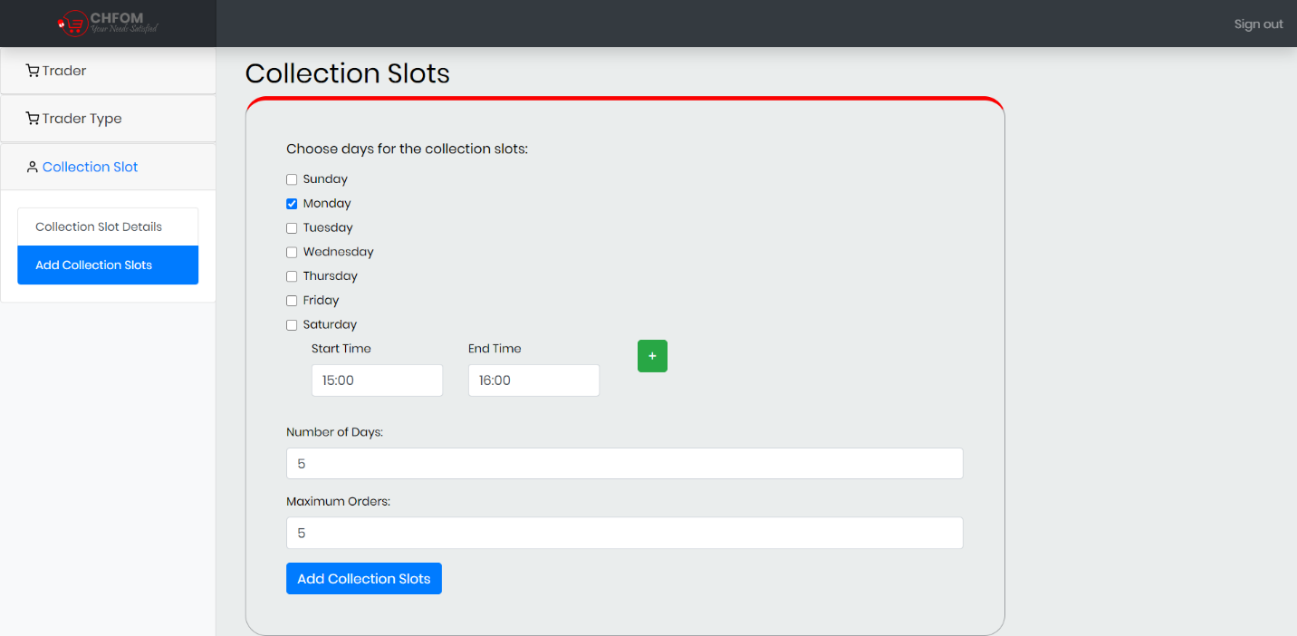 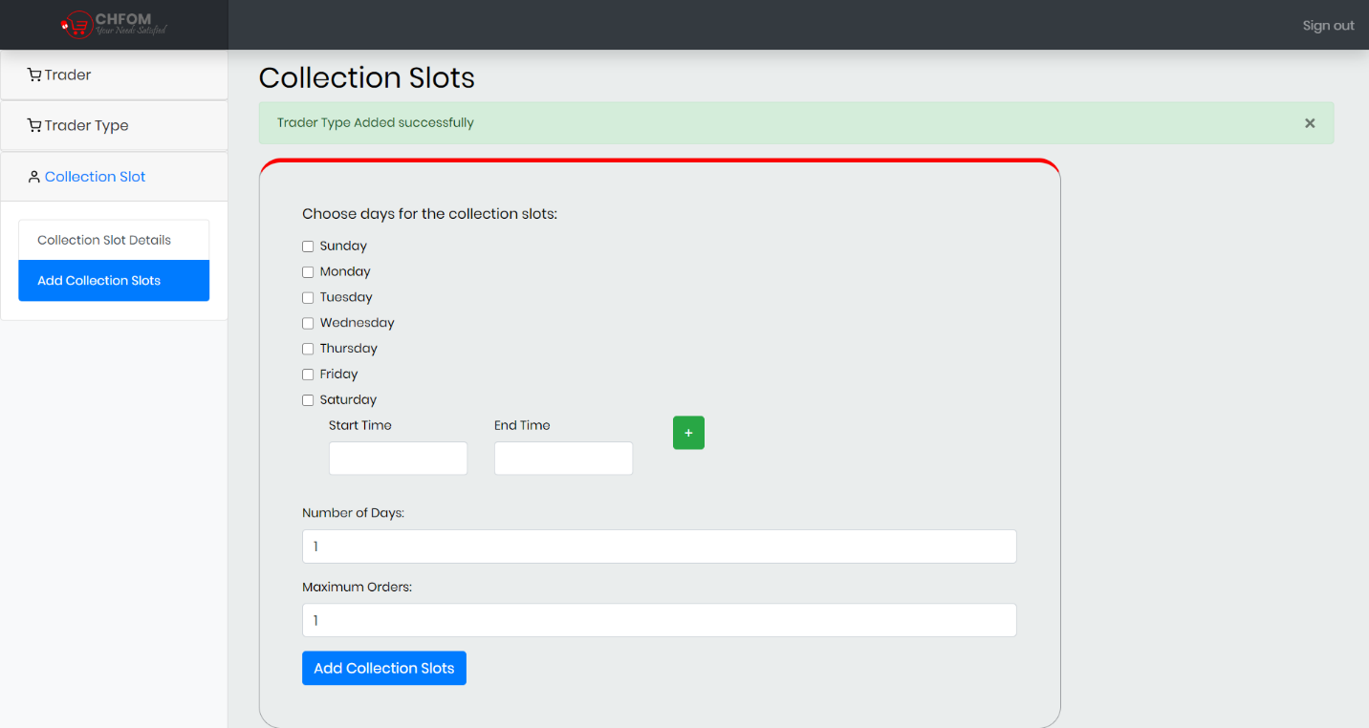

## Access Trader Account

Expected Result:

## 